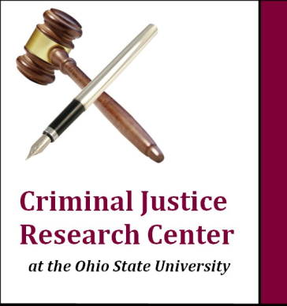
CJRC
Undergraduate Internship Program Fact Sheet

Founded January 2012
Information updated December 2016

As CJRC interns, students gain experience in crucial aspects of social science research, including working with primary and secondary data related to offenders/offenses, victimization, mental health, law enforcement and/or criminal justice processes. Students learn various techniques in qualitative and quantitative analysis and the ways these are used to measure organizational success, develop funding sources and impact public policy. This is an outstanding opportunity for OSU undergraduates to gain valuable, practical experiences for graduate/professional school and future careers. CJRC maintains a commitment to finding students from diverse backgrounds who share a common passion for social science research and a dedication to academic excellence.

Our interns:

- Typically junior or senior-level students at OSU
- Interns must have a minimim 3.5 cumulative GPA, with honors status preferred
- Prior research experience is preferable but not always required
- Interns must make a minimum one-semester commitment, with work hours varying
between 10-20 hours per week, depending on the project
- Interns have the opportunity to earn academic credit in sociology internship/research.
- Interns must keep brief logs of hours worked and activities completed for the purposes
of CJRC records, turned in at the end of each academic term

Progress in the internship program to date:

- As of December, 2016, 187 students have been placed. In the Fall term of 2016, 41 students are actively placed. CJRC students have interned with: Criminal Justice Research Center , Ohio Department of Rehabilitation and Correction, Ohio Department of Public Safety, Ohio Office of Sustainability and Conservation, Franklin County Probation Dept., Office of Criminal Justice Services, Ohio Public Defender, Ohio Department of Homeland Security, Columbus Police Department, Dr. Devin Fergun, Dr. Creola Johnson, Youth Enterprise Institute, Delaware County Reentry and the Ohio Department of Youth Services.
- Potential placement announcements are made through the OSU Undergraduate Research Office, classroom announcements, the Sociology/Criminology Undergraduate Advising Office, CJRC Newsletter and website.
- To date, CJRC has received approximately 708 inquiries from students via email or phone, and 234 students have been interviewed.
- Matched students’ majors include: Sociology, Criminology, Economics, Psychology, Actuarial Science, Math, Geography, Public Affairs, National Security Studies, International Studies, Political Science, History, English, Women’s Studies, Arabic, Spanish, French, Journalism, Social Work, Agriculture and Pre-Law concentrations.
- Matched students’ average cumulative GPA is 3.6, and most have plans to attend law school, graduate school, and/or to work in criminal justice or related fields.

For further information on the CJRC Undergraduate Internship Program, please contact: (Christopher Yanai, Program Manager (614) 688-8685, Email: Yanai.7@osu.edu)

